00.03
Technical Assistance
Process Design & AMOS Configuration Document
Purpose
This Process Design document is provided to Key-Users to record their key decisions regarding the AMOS Process design and the required AMOS configuration.
It is updated throughout the Project Definition Phase and used as the baseline for the Final Acceptance prior to Go-Live
Revision
Author, Name | Date | Notes
ADKE Adam Kelemen | 14.05.2024 | First version

Table of Contents
1. Process Overview & Objectives 3
2. Regulatory References 3
3. Definitions & Glossary 4
4. Process Tasks 4
5. Process Dependencies 4
6. Process Flow 5
7. Process Design Questions 6
8. Data (Source) Mapping 7
9. Other Software Used 7
10. AMOS Configuration 8
a. Basic Data 8
b. Parameters 8
c. Workflows 9
d. Scheduled Tasks 9
e. API’s & Interfaces 9
11. Annex – Additional Info 9

Process Overview & Objectives

Process General Description:
This process will help the AMOS Competence Center (ACC) to deploy and use Technical Assistance (APN 869) within your AMOS.
Technical Assistance is a tool to collect and track issues that can come up in your daily AMOS usage. It is often directly integrated into certain main AMOS APN-s like APN 1418 Workorder or APN 2121 Goods Receiving. Additionally, the details within the query can be direct links, instead of free text. This ensures fast identifications of the problematic areas.
Typical examples of issues are:
- No access rights to certain modules
- Wrong serialnumber installed in AMOS.
- Labelbooking not possible due to various errors.
- Goods receiving not possible due to various errors.
- Etc...
With this process, ACC will make sure that the necessary access rights and parameters are configured for daily usage. Ideally, majority of the AMOS users should have access rights to open Technical Assistance Queries.
Once there are queries being opened, ACC must ensure that the issues are followed up, monitored and fixed.
If the issue cannot be fixed internally, ACC must open a support case at Swiss-AS.

Main Process Objective (Outputs & Outcomes) :
The main stakeholders in the Technical Assistance process are:
- The day to day business users. If they are stuck because of an AMOS related issue, they must open a technical query.
- Amos Competence Center (ACC). Usually, ACC is responsible to monitor and manage AMOS technical queries. They must either fix the issue, assign it to the people who can fix it, or forward it to Swiss-AS as a Support Case.
- The quality department has a good chance here to analyse trends or identify key areas where improvements can be made, or extra training is necessary.

Regulatory References

- -

Definitions & Glossary

Key-Words | Explanation
ACC | AMOS Competence Center
Technical Query | An issue raised in APN 869. This is internal within your company. It’s closed when the issue is resolved.
Support Case | An issue or request raised by Your Company to Swiss-AS. Since this is external communication, there is an option so that this can be seen by other AMOS Customers.
Business Users | The people who work in AMOS.
User Role | A package of read/write rules related to different AMOS APN-s. Defined in APN 15, assigned in APN 14.

Process Tasks

Business Process Task / Actions / Activities :
- ACC must make sure to determine each User Role is configured for Technical Assistance usage.
All or selected business users must be able to raise and read technical queries.
The ACC must be able to fully manage technical queries. (Open, Close, Assign, Give due date, Close, Reopen etc..)
- ACC must make sure that the workflows are set up
- Business users must raise new cases if they encounter AMOS issues.
- Quality and ACC must monitor the cases.
- ACC must manage the cases. (Open, Close, Assign, Give due date, Close, Reopen etc..)
- ACC must open Swiss-AS support case, if the issue cannot be solved internally.

Process Dependencies

- Another process: 00.08 – Support Tool
- Other APN-s have a button to directly open a technical query.
  - APN 1418 Workorder
  - APN 2121 Goods Receiving

Process Flow
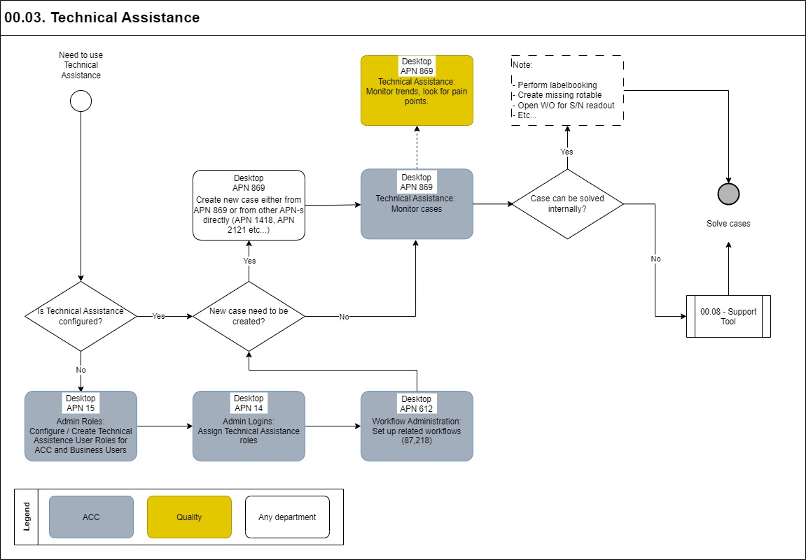

Process Design Questions

# | Question | Answer
1
2
3
4
5
6

Data (Source) Mapping

Data Sources | Description | Volume / Manual / Automatic / Static / Dynamic
Swiss-AS support cases | Can be used to look around when trying to solve an issue | Dynamic data, enriched daily
Internal technical queries | Can be used to look around when trying to solve an issue | Dynamic data, enriched daily
All AMOS objects | To issue a technical query, you need to link it to something existing in AMOS. | Dynamic data, enriched daily

Other Software Used

Other Softwares | Used by: | Description
-

AMOS Configuration

Basic Data

Basic Data Table | Notes
Many | Tech queries cannot be just “free floating”. They must be linked to an AMOS object. Examples: Workorder, Order, Maintenance Event, Pickslip etc....  These must exist prior issuing a technical query.

Parameters

Parameter Code | Parameter Name | Notes
1460 | ASSIGN GROUP MANDATORY | Set to “Y”, the user can configure to pre-fill Assigned To / Group field automatically. Otherwise it’s empty.
1467 | FOLDER FOR SUPPORT QUERY SCREENSHOTS | Webdrive folder where the screen-shots from Support Queries are stored.  Example: support_query/
1468 | BEHAVIOUR OF TECH.ASSIST. BUTTON IN WORKORDER | Integer = 0: The user is asked what to do.  Integer = 1: Workorder query  Integer = 2: Aircraft query
1491 | INTERRUPTED TECH QRY FOR WORKORDERS | With the string value you can decide whether workorders with open queries in Technical Assistance can be assigned to a workpackage or not.
1763 | Allow assignment of Technical Query to inactive user | This parameter is used to setup whether the assignment of a Technical Query to an inactive user is allowed or not.

Workflows

Workflow Number | Workflow Name | Notes
87 | Technical Query Progress
218 | Remind soon to be Due Technical Queries
524 | Remind not assigned Technical Queries

Scheduled Tasks

Scheduled Task Reference | Frequency | Notes
TechnicalAssistantQueryAssignmentCheck | Max Daily, can be less frequent | This task will trigger a workflow 524 to inform people about Technical Assistance Queries that needs to be assigned.
TechnicalAssistantQueryReminderService | Max Daily, can be less frequent | This task will trigger a workflow 218 to inform people about Technical Assistance Queries that are due soon.

API’s & Interfaces

Reference | Direction | Trigger | Frequency
-

Annex – Additional Info

